Github links
Multimodal samrt wearable device
https://github.com/Naveen-Khan/Multimodal-Smar-Wearable-Device-For-Personal-Saftey: The Multimodal Smart Wearable Device for Personal Safety integrates multiple emergency detection technologies into one compact wearable unit.

Macdonals customer support agent
github
https://github.com/Naveen-Khan/Machdonals-ai-agent

Cati chatbot
https://github.com/Naveen-Khan/Ai-RAG-Based-Chatbot

Clinical data analysis
github
https://github.com/Naveen-Khan/Ai-Based-Clinical-Data-Exprorar-Analysis

Live link
https://clindata-frontend.agreeablehill-90bfeb84.centralindia.azurecontainerapps.io

AI · HEALTHCARE · CLINICAL DECISION SUPPORT
CardioRisk AI — Clinical Decision Support System
An intelligent web application that predicts heart disease risk using 13 clinical variables with 97.6% accuracy. Powered by Support Vector Machine (SVM) and validated on 3,800+ patient records, the platform delivers real-time risk stratification, and multi-format medical reports (PDF, CSV, Excel). Logistic Regression baseline (80.5% accuracy) included for clinical comparison. Deployed globally via Vercel.
Machine Learning ,Next.js, Python ,SQLite ,Tailwind CSS ,Vercel
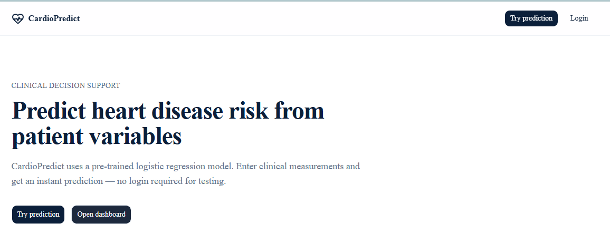
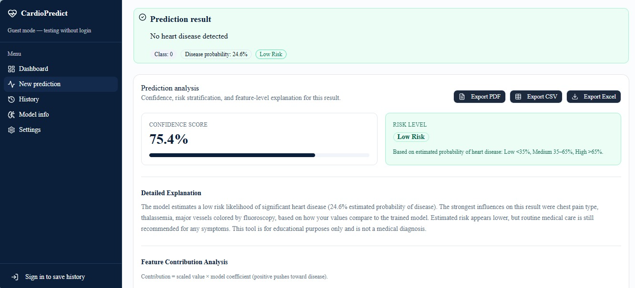

live
https://web-un87u2afa-naveenkhan0111-4662s-projects.vercel.app/
Github

OutreachAI — Smart Email Outreach Agent
An AI-powered email automation agent built with n8n that sends 50+ personalized sales emails daily to potential clients. The system automatically reads company data from Google Sheets, generates tailored outreach emails using LLMs, sends them without manual intervention, and logs all email content back to the sheet. Reduced manual effort by 90% while maintaining a cost of approximately $0.02 per email.
N8n ,OpenRouter AI LLMs ,Google Sheets ,Gmail api ,JavaScript ,GCP

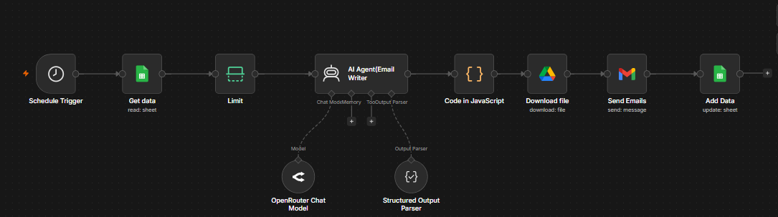

Github
https://github.com/Naveen-Khan/Smart-Email-Outreach-Agent

RevenueAI — Sales Forecasting Based on Advertisement
An intelligent sales forecasting platform powered by Polynomial Regression. Analyzes advertising investments across TV, Radio, and Newspaper channels to predict future sales, optimize marketing budgets, and deliver actionable business insights through an interactive dashboard. Achieved 95.3% R² accuracy with 0.903 MAE, validated through enabling businesses to make data-driven marketing decisions with confidence.
Machine Learning ,Polynomial Regression , Python , Streamlit
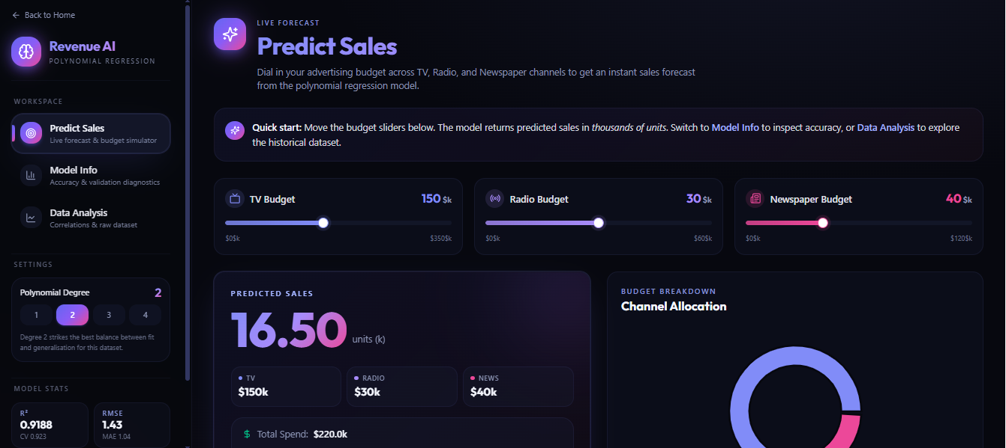

Github
Naveen-Khan/RevenueAi

Radiomed
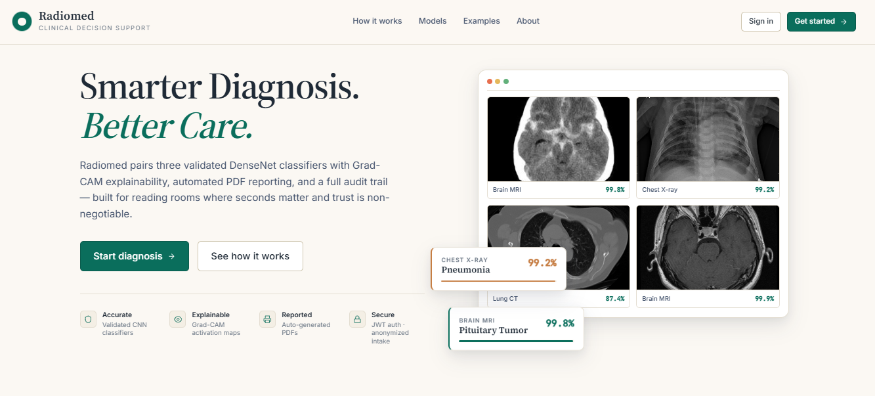

Order of project
Clinical data exprorar
Enterprise Rag
Machdonals ai customer support agent
Radiomed
Revenue ai
outreach
Multimodal Smart wearbe device

Github links
Multimodal samrt wearable device
https://github.com/Naveen-Khan/Multimodal-Smar-Wearable-Device-For-Personal-Saftey: The Multimodal Smart Wearable Device for Personal Safety integrates multiple emergency detection technologies into one compact wearable unit.

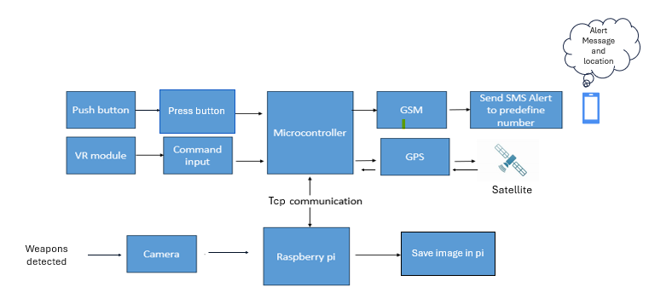
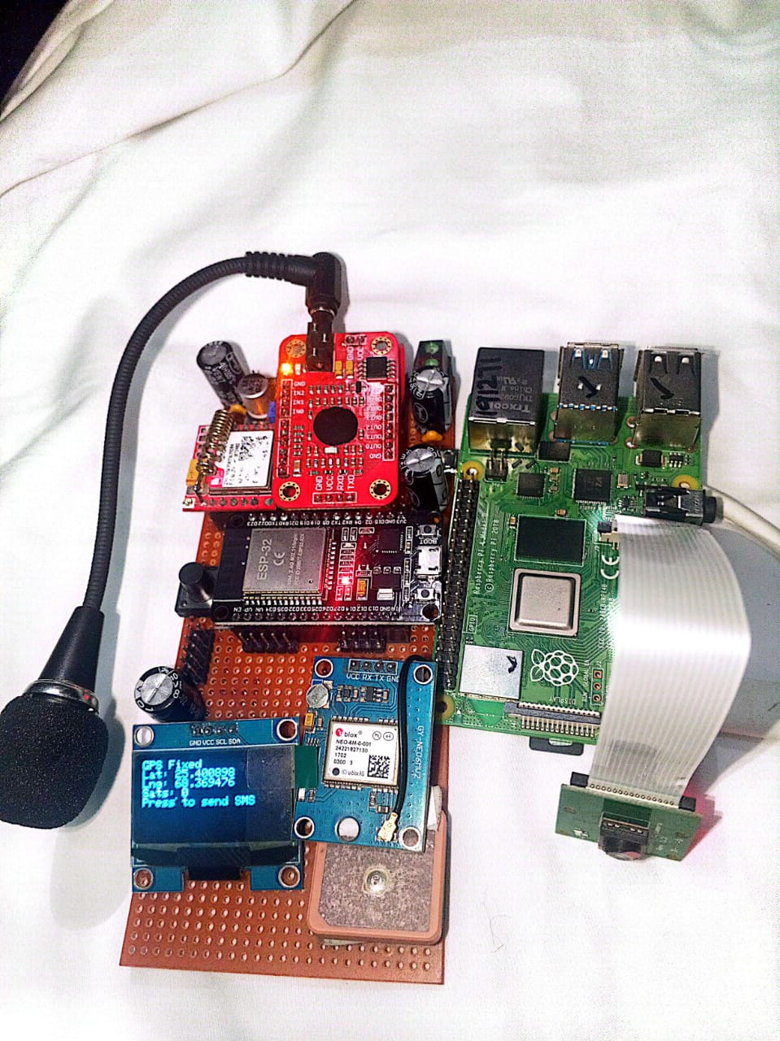

Rag system

